

A PROJECT REPORT ON
“COTTON COUNTY LTD.”

BY
VINAY B.KAMBLE
PIYUSH R. TAMASKAR

IN FULFILLMENT OF THE
BACHELOR IN COMPUTER APPLICATION

GUIDED BY FACULTY

PROF.GAUTAM BAPAT
MRS.ARCHANA KOTHAWDE

Certificate

This is to certify that Mr.Vinay.B.Kamble and Mr.Piyush.R.Tamaskar student of Bachelor of computer application has successfully completed Software development Project in partial fulfillment for the course of Bachelor of computer application under University of Pune, for the academic year 2010-2011.

Internal Guide Course In charge
______________ ______________

______________
Principal

Date: ___/___/______

External Examiners:

College Seal
1. ____________________________
2. ____________________________

ACKNOWLEDGEMENT



ACKNOWLEDGEMENT

We are Very grateful to present the Project on

“COTTON COUNTY LTD.”

We would like to take this opportunity to thank all those who helped me to complete this project with their Guidance, Co-operation and support.

We would like to thank our faculties Prof.Gautam Bapat and Mrs.Archana Kothawde for their valuable guidance.

We also owe special thanks to our friends for providing the friendly and cordial environment to achieve the goal, without their contribution this project would not have been successful.

Most importantly we thank our parents who guided and supported us simultaneously in project and achieving goal.

Vinay .B. Kamble

Piyush .R. Tamaskar
(T.Y.BCA)

INDEX

- INTRODUCTION TO PROJECT
- Scope of System
- Existing System
- Drawbacks & Limitations
- Need of System

- PROPOSED SYSTEM
- Objectives of Proposed System
- Functioning
- User Requirements

- FEASIBILTY STUDY

- REQUIREMENT ANALYSIS

- ENTITY RELATIONSHIP DIAGRAM

- DATA FLOW DIAGRAM

- CONTEXT LEVEL DIAGRAM

- DATA DICTONARY

- PROGRAM SPECIFICATION

- USERS MANUAL

- FORM DESIGN

- BIBLIOGRAPHY
 | INTRODUCTION TO PROJECT

The “COTTON COUNTY LTD.” project is important software needed in rural areas and urban areas.

It deals with the various levels of cotton processing plant right form when the cotton crops are prepared to grow till they are received on the processing plant. It is designed for cotton agent from a village. This agent visits all near-by villagers and farmers, purchases cotton as per as the rate decided by government and to book the cotton from farmers. He makes some advance payments.

Raw cotton is given by farmer which is cleaned filtered & spin & pure cotton is recorded. After spinning cotton 30% loss is recorded. This cotton is sold to cotton industries in tax wise.

This gives the management a clear picture of the usage of time. It also gives the management the details of the farmers whose farms are been booked by them. It keeps a record of the payment made to the farmers and also balances left.

At the end agent wants to find out following report:
- Village wise sale of cotton.

- Stock of cotton on daily basis.

- Payment & advances made to farmers.

Front End : JAVA
Back End : Microsoft Access

SCOPE OF SYSTEM

- This system will perform multi-user as well as multilevel access/authority.
- One person can handle whole system, so it will require less manpower.
- Transfer of data is faster due to which the frequency of work increases.
- Record of Farmers, Customers, Products, Bills, Receipts can be easily maintain and retrieve.
- Investment required for this system is less and maximum output is generated.
- Security of data can be more than the existing system and other system.
- System is more effective than the existing system.
- More accurate output in less time.

EXISTING OF SYSTEM

The Existing System is a manual one or in Excel Sheets and hence it takes a long time to search through the various records of the Farmers, Customers, Stocks, Bills & Receipts for some specific information.

It is difficult to maintain accurate details, update the details and records as well as to retrieve the stored information.

DRAWBACKS & LIMITATIONS OF SYSTEM

- A lot of paper work is required as this system is manual. Hence maintenance and keeping a data backup is not easy.

- Man power requirement is more in current system and working hours of the employee cannot be utilized adequately.

- Manual errors in data entry and reports are more probable due to human errors.

- Different types of records are stored in numerous registers. Retrieval of such records is a time consuming process which may reduce working efficiency and need a considerable physical storage space.

 | NEED OF SYSTEM

Before making of this software we first made the list of the need for this software and then only we could manage to move further.

The need of the software is as follows:

- To design and develop a system as user friendly as possible.

- To reduce Clerical Work.

- This not only reduces manual work but also time and storage requirements.

- To provide the data according to users way.

- To improve Data Accuracy, Integrity, Consistency, Retrieval of Information and processing speed.

 | PROPOSED SYSTEM

The Cotton County System will keep track of all the Farmers, Customers, Bills Receipts, Stock records on the computer and one can get every record related to a Farmer & Customer very easily with the help of this present system.

The system helps in computerization of all the personnel and executive details so that no one has to keep anything manually and fear of loss of valuable records.

The proposed system here will overcome all the loopholes of the old system and bring a new one with much easier to operate and faster in fetching any desire information about anything related to the project.

The new system will also be able to produce reports as per the requirement so the proposed system will make the work very easier and fast with the better than its ancestor.

Designing and implementing it accordingly will give a vast value of information regulation to each and every person of the firm. We can also modify the system as in the future.

OBJECTIVES OF PROPOSED SYSTEM

- As compared to manual work this system is much faster and saves a lot of time.

- Unauthorized person cannot access the data as security of data is maintained.

- There is less dependency on employee and high efficiency in the actual work.

- Record keeping becomes easier.

- Sharing of data is possible at secure level.

- Ease of use.

- Simple to management.

- Instant updating of information.

- Keeping the system scalable.

FUNCTIONING

It will be quiet easy system to work on. When Cotton is received by the Employee of the organization and he will check into the details and accordingly fill in the details in Master Screens.

First all the details with all the specific requirements will be studied by the Employee then he will make reports according to it.

The Record is made as per the stock reports, customer reports & Farmers reports. Details are been saved billing and receipts are made by this records which saves and work.

USER REQUIREMENTS

To determine the user’s requirement the following points are taken into consideration:-

- The system should be user friendly and attractive.
- The system should maintain the personnel details (i.e. the details of the Employee).
- Give Accurate Reports on the following:
  - Stock Report
  - Village Wise Report
  - Outstanding Customer Report
  - Outstanding Farmer Report
  - Total Customer
  - Payments Done by Cheque & Cash

So the system should be developed in such a way that it meets the end user requirements and need.
- The system should be economically feasible.
- The system should be easily maintained and enhanced.

 | FEASIBILITY STUDY

The feasibility study of this project covers the 3 major aspects namely Technical, Economical, Operational.

- TECHNICAL FEASIBILTY:
Technical feasibility centers on existing system for hardware and software and to what extent it can support the proposed system. The current technical resource available in the organization is capable of handling user requirements. Therefore technical feasibility of the proposed system is not the constraint. The existing hardware and software at quality precision gauges is capable of handling proposed system.

- ECONOMICAL FEASIBILTY:
Economical feasibility the most important factor to be always remembered for the success and effectiveness of the system.
Economically the basic factors to be considered are:
- Cost of doing the entire system study.
- Estimated cost of hardware and software.
Economically this project doesn’t raise any issues, as the project itself is planned or aimed for the common people to use it.

- OPERATIONAL FEASIBILTY:
As the system is developed using state of the art and highly calibrated it is very easy in terms of its operation as it comes up with the current technologies and practices.

The designed system uses systematic approach and easy to understand and use. System is user friendly and at each and every necessary messages and information us given.

The end user need not have a deep knowledge of computer and a little formal training is required for the operating system.

 | REQUIREMENT ANALYSIS

Hardware Specification:

- RAM 512MB or Faster

- Free Space For Software Installation

- Printer for Printing

- Processor 300Mhz Pentium 4 or any equivalent processor

- Hard Disk 40GB

- Input Devices: Keyboard & Mouse

Software Specification:

- Operating System- Windows 7,Vista,XP,2000

- Other Operating System – Linux or MAC

- Java Development Kit 1.6 or higher version

 | ENTITY RELATIONSHIP DIAGRAM

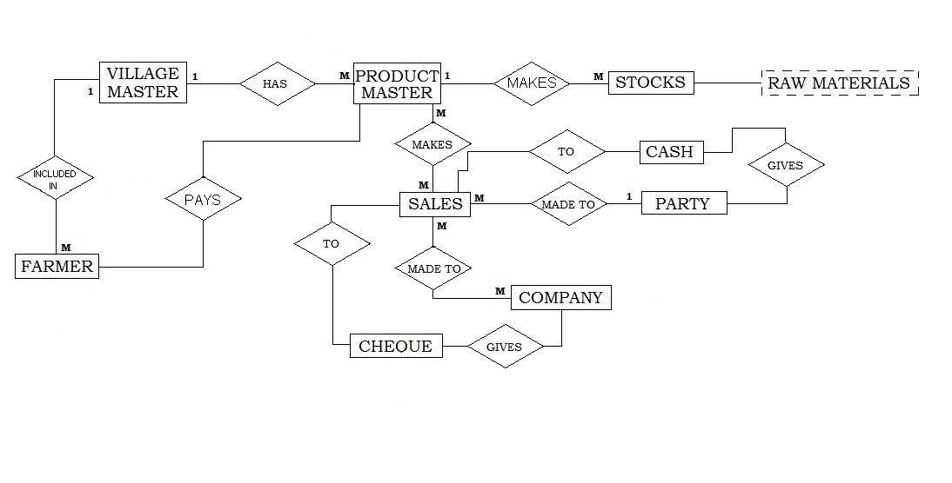

DATA FLOW DIAGRAM

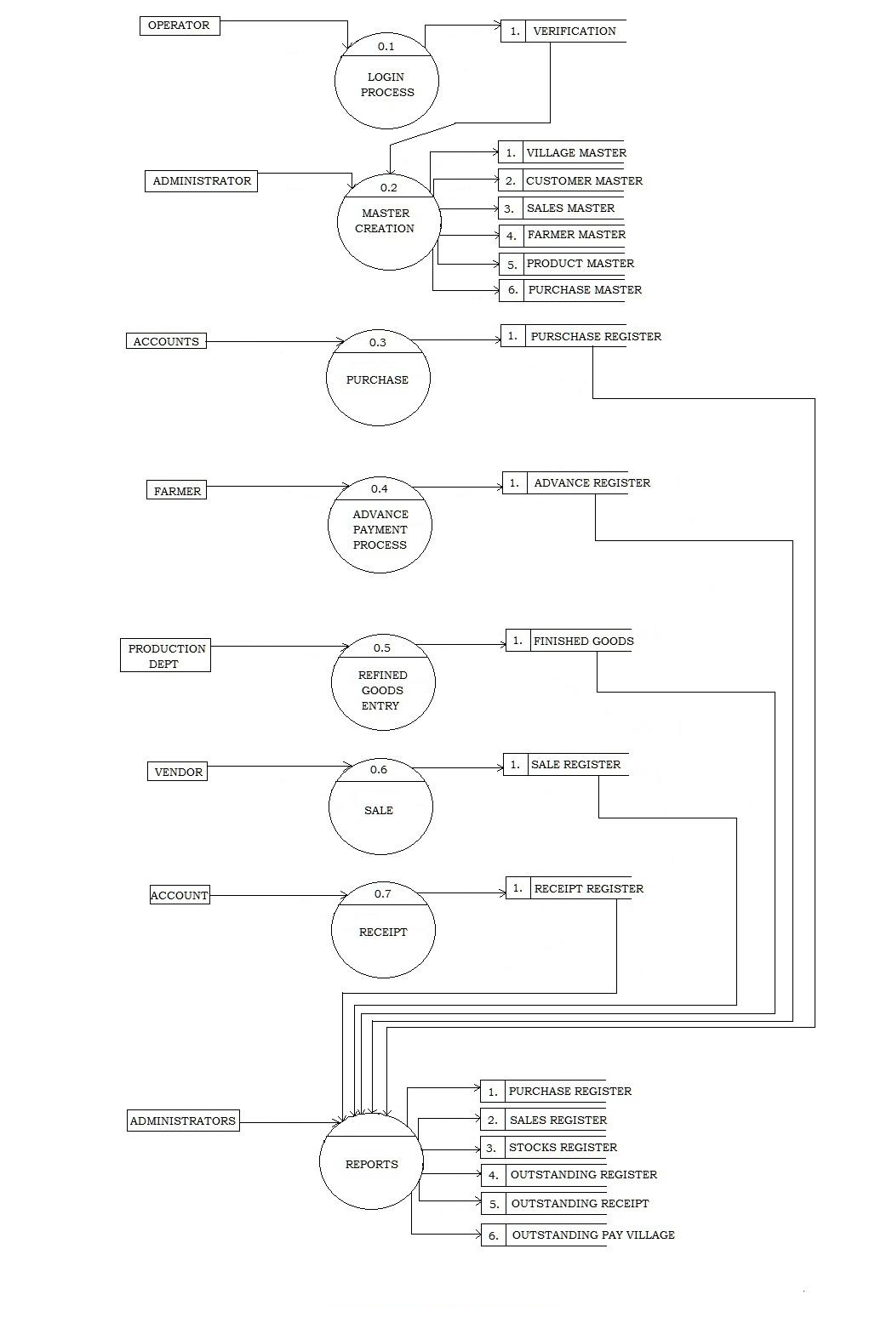
 | DATA DICTONARY

- VILLAGE RECORD

SR NO | FIELD NAME | DATATYPE | FIELD SIZE | DESCRIPTION
1 | VillageID | Auto number | Long | Primary Key
2 | Village Name | Text | 50 | Enter Village Name
3 | City Name | Text | 50 | Enter City Name

- PRODUCT RECORD

SR NO | FIELD NAME | DATATYPE | FIELD SIZE | DESCRIPTION
1 | ProductID | Auto number | Long | Primary Key
2 | Product Name | Text | 50 | Enter Product Name
3 | Product Rate | Number | 50 | Enter Product Rate

- FARMER RECORD

SR NO | FIELD NAME | DATATYPE | FIELD SIZE | DESCRIPTION
1 | FarmerID | Auto number | Long | Primary Key
2 | Farmer Name | Text | 50 | Enter Farmer Name
3 | Village Name | Text | 50 | Enter Village Name
4 | VillageID | Number | Long | Enter Village ID
5 | Village City | Text | 50 | Enter Village City
6 | Address | Text | 50 | Enter Address
7 | Birth Date | Date/Time | 50 | Enter Birth Date
8 | Contact | Text | 50 | Enter Contact
9 | Gender | Text | 50 | Enter Gender

- CUSTOMER RECORD

SR NO | FIELD NAME | DATATYPE | FIELD SIZE | DESCRIPTION
1 | CustomerID | Auto number | Long | Primary Key
2 | Customer Name | Text | 50 | Enter Customer Name
3 | Customer Type | Text | 50 | Enter Customer Type
4 | Address | Text | Long | Enter Address
5 | Contact | Number | 10 | Enter Contact Number

- PURCHASE RECORD

SR NO | FIELD NAME | DATATYPE | FIELD SIZE | DESCRIPTION
1 | Inward No | Auto number | Long | Primary Key
2 | Inward Date | Date/Time | 20 | Enter Inward Date
3 | Receipt No | Number | Long | Enter Receipt No
4 | Farmer Name | Text | 50 | Enter Farmer Name
5 | FarmerID | Number | Long | Enter Farmer ID
6 | Address | Text | 50 | Enter Address
7 | Village Name | Text | 50 | Enter Village Name
8 | Total | Number | 30 | Enter Total Amount

- PURCHASE DETAILS

SR NO | FIELD NAME | DATATYPE | FIELD SIZE | DESCRIPTION
1 | Inward No | Auto number | Long | Acts As Foreign Key
2 | Receipt No | Number | Long | Enter Receipt No
3 | Product Name | Text | 50 | Enter Product Name
4 | Product Rate | Number | Long | Enter Product Rate
5 | UnitKG | Number | Long | Enter Tonnes
6 | Total | Number | 30 | Enter Total Amount

- SALES RECORD

SR NO | FIELD NAME | DATATYPE | FIELD SIZE | DESCRIPTION
1 | Sales No | Auto number | Long | Primary Key
2 | Bill No | Number | Long | Enter Bill No
3 | Customer Name | Text | 50 | Enter Customer Name
4 | Customer ID | Number | Long | Enter Customer Rate
5 | Customer Type | Text | 50 | Enter Customer Type
6 | Address | Text | 50 | Enter Address
7 | Bill Date | Date/Time | 20 | Enter Date
8 | Total | Number | 50 | Enter Total Amount

- SALES DETAILS

SR NO | FIELD NAME | DATATYPE | FIELD SIZE | DESCRIPTION
1 | Sales No | Auto number | Long | Acts As Foreign Key
2 | Bill No | Number | Long | Enter Receipt No
3 | Product Name | Text | 50 | Enter Product Name
4 | Product Rate | Number | Long | Enter Product Rate
5 | UnitKG | Number | Long | Enter Tonnes
6 | Vat | Number | 10 | Enter Vat
7 | Total | Number | 30 | Enter Total Amount

- CUSTOMER BILL

SR NO | FIELD NAME | DATATYPE | FIELD SIZE | DESCRIPTION
1 | Sales No | Auto number | Long | Acts As Foreign Key
2 | Customer Name | Text | 50 | Enter Customer Name
3 | Customer ID | Number | Long | Enter Customer ID
4 | Customer Type | Text | 25 | Enter Customer Type
5 | Bill No | Number | Long | Enter Bill No
6 | Bill Date | Date/Time | 20 | Enter Bill Date
7 | Address | Text | 50 | Enter Address
8 | Payment Type | Text | 20 | Enter Payment Type
9 | Cheque No | Number | 15 | Enter Cheque No
10 | Cheque Date | Date/Time | 20 | Enter Cheque Date
11 | Amount | Number | 50 | Enter Total Amount
12 | Bank Name | Text | 50 | Enter Bank Name

10) FARMER RECEIPT

SR NO | FIELD NAME | DATATYPE | FIELD SIZE | DESCRIPTION
1 | Farmer ID | Auto number | Long | Acts As Foreign Key
2 | Farmer Name | Text | 50 | Enter Farmer Name
3 | Inward No | Number | Long | Enter Inward No
4 | Inward Date | Date/Time | 25 | Enter Inward Date
5 | Receipt No | Number | Long | Enter Receipt No
6 | Address | Text | 50 | Enter Address
8 | Payment Type | Text | 20 | Enter Payment Type
9 | Total Amount | Number | 35 | Enter Total Amount
10 | Advance Paid | Number | 35 | Enter Advance Paid
11 | Balance Remained | Number | 35 | Enter Balance Remained

 | PROGRAM SPECIFICATION

    - Form Name : LoginScreen.java
This is the Login window. It requires for the user to enter correct username and password for viewing the Main screen which facilitates entry of data and also display various output reports.

    - Form Name : Mainscreen.java
This is the core form. It provides the user with a choice of Data entry forms; Transaction forms and Reports so that he can choose the desired Option.

    - Form Name : VillageMaster.java
This is the form where a new village id is created with the village name and the
City name. Record is maintained with different village information.

    - Form Name : ProductMaster.java
Each and Every new Product is entered here by deciding the amount of the
Product which is applicable for both customer and the farmer.

    - Form Name : FarmerMaster.java
Before purchasing material, information is stored by creating a new Farmer
Record and is further processed by its unique ID for Receipt making or search
Related.

    - Form Name : CustomerMaster.java
Before supplying material, information is stored by creating a new Customer
Record and is further processed by its unique ID for Bill making or search
Related.

    - Form Name : FarmerReceipt.java
In this all the transaction is made by storing the information like material quantity, total amount and the payment type.
In Short a Receipt is made and saved which is given to farmer.

    - Form Name : CustomerBill.java
In this all the transaction is made by storing the information like material quantity, total amount and the payment type.
In Short a Bill is made and saved which is given to Customer.

    - Form Name : StockReport.java
Here all the information can be displayed by how much was the Inward quantity, Sale Quantity of the product and balance of the product.

10) Form Name : OutstandingFarmerReport.java
In this form a report is been showed of which farmer has got the advance payment and which has got the full payment.
Thus, it displays the result with balance remaining.

11) Form Name : OutstandingCustomerReport.java
In this form a report is been showed of which Customer has done the payment by cheque and cash.
It also displays the Bill no of the customer.

12) Form Name : CustomerReport.java
It displays the total Number of Customer with all the information related to it.

13) Form Name : VillageWiseReport.java
It displays the total Number of Farmer in a certain village with all the information related to it.

 | USER MANUAL

Main Page consists of following things:
- Master Creation
- Transactions
- Reports
- About US
- Help

- Master Creation:
- Village Master
- Product Master
- Farmer Master
- Customer Master

- Transactions:
- Customer Bill
- Farmer Receipt

- Reports:
- Stock Report
- Customer Report
- Village Wise Farmer Report
- Outstanding Customer Report
- Outstanding Farmer Report

 | FORM DESIGNS

LOGINSCREEN

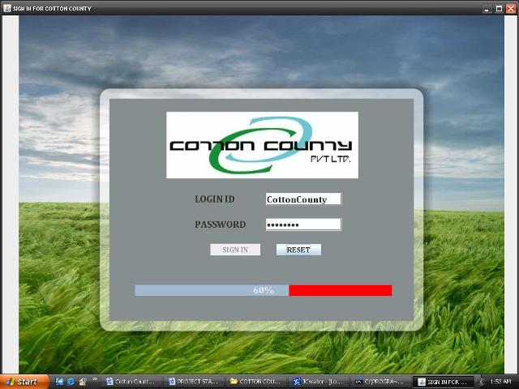

MAINSCREEN

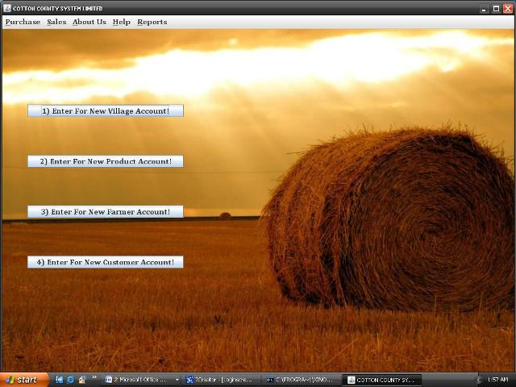

Village Record

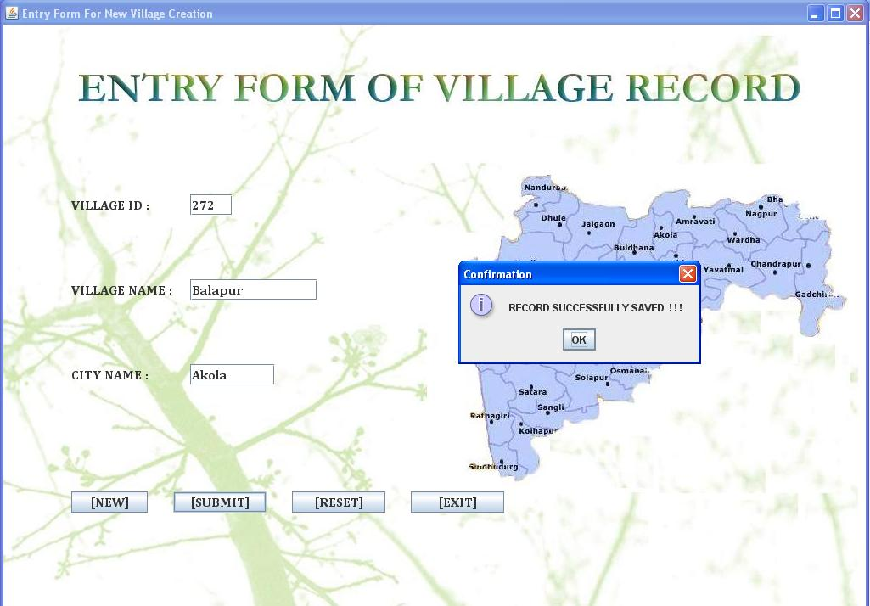

PRODUCTSCREEN

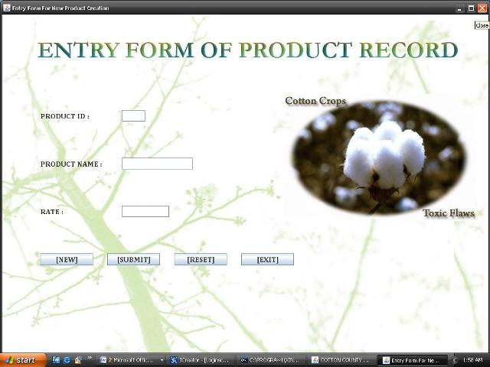
CUSTOMER SCREEN

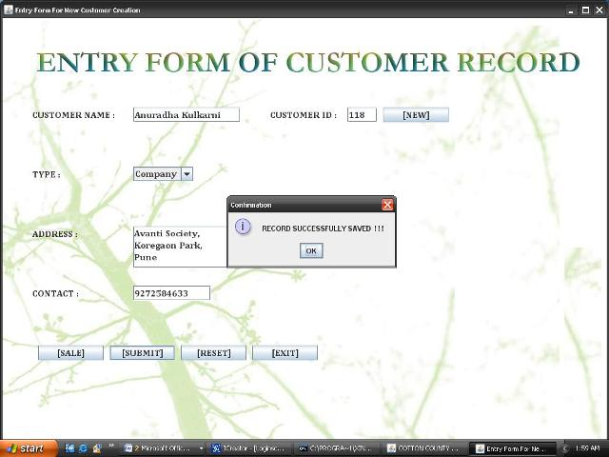

ENTRY FORM RECORD
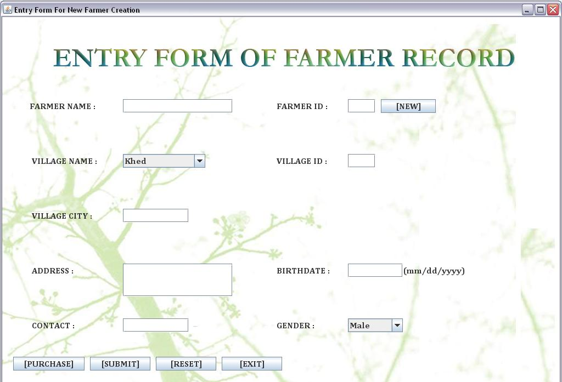

SELLING OF PRODUCT

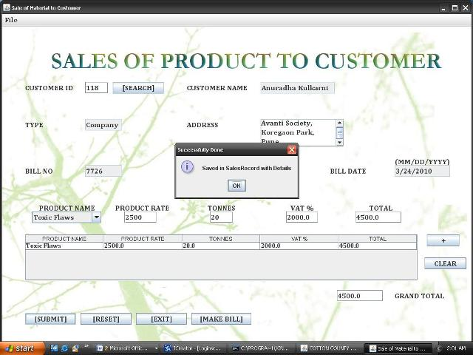
PURCHASE OF PRODUCT FROM FARMER
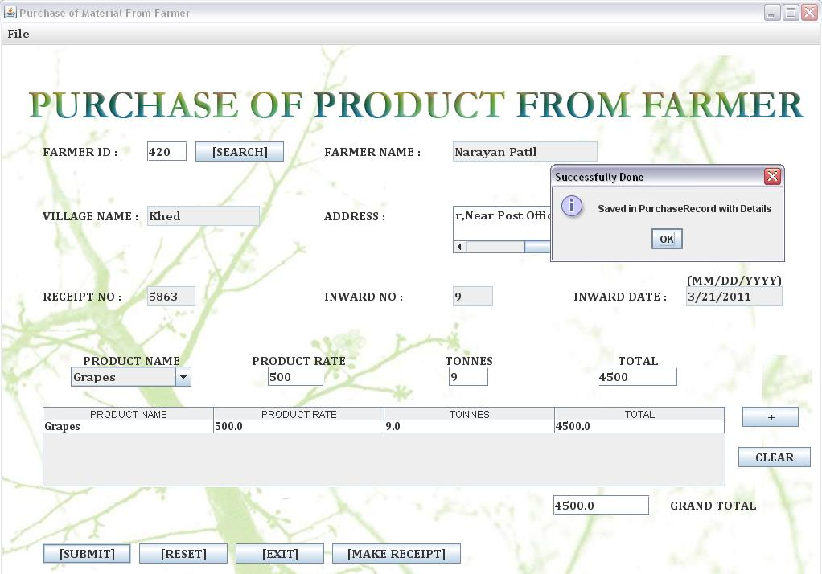

CUSTOMER BILL

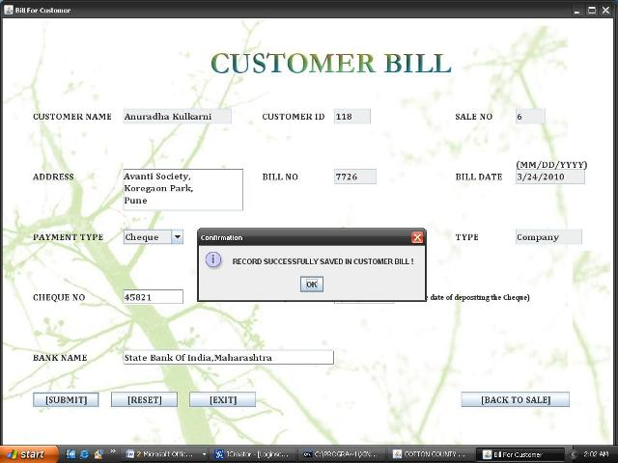

CUSTOMER REPORT

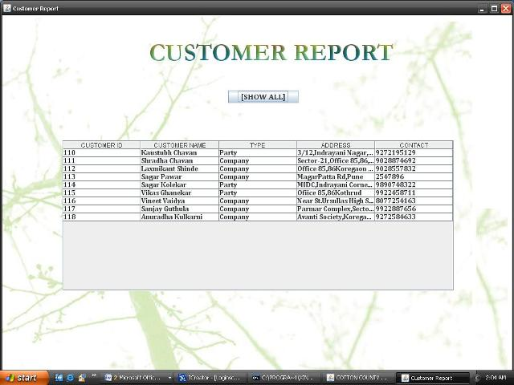

STOCK REPORT
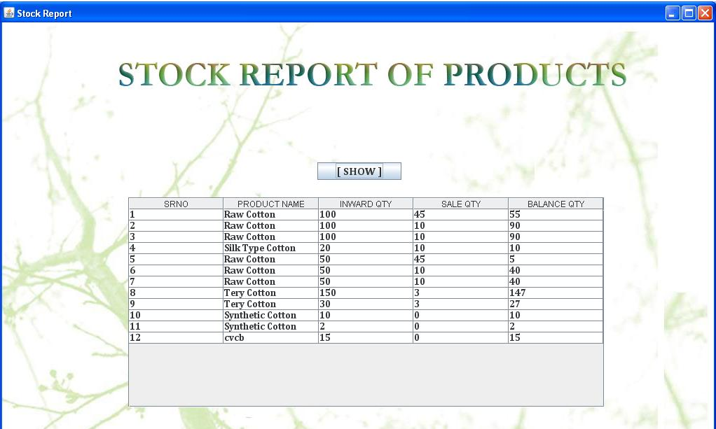

OUTSTANDING FARMER REPORT
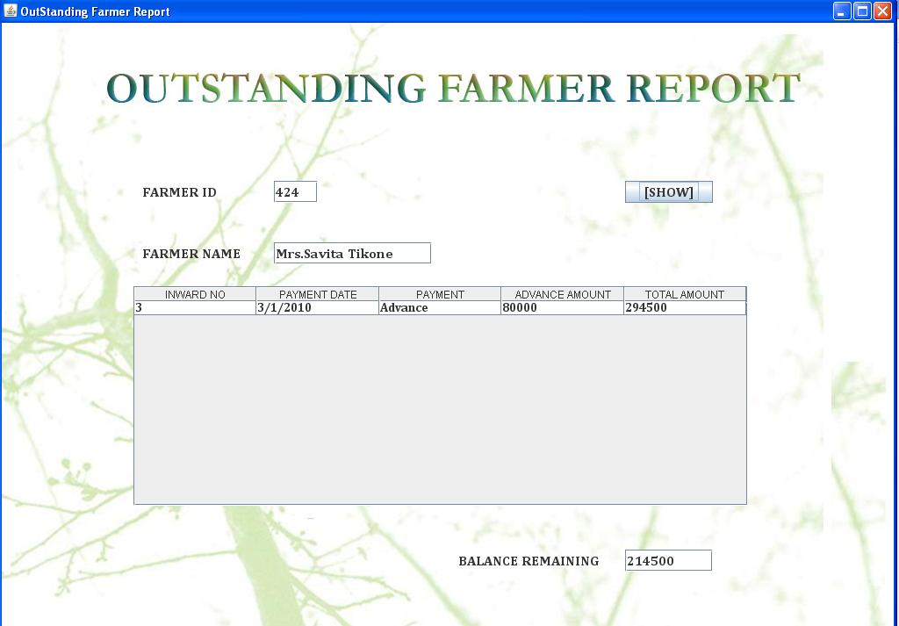

OUTSTANDING COUSTOMER REPORT
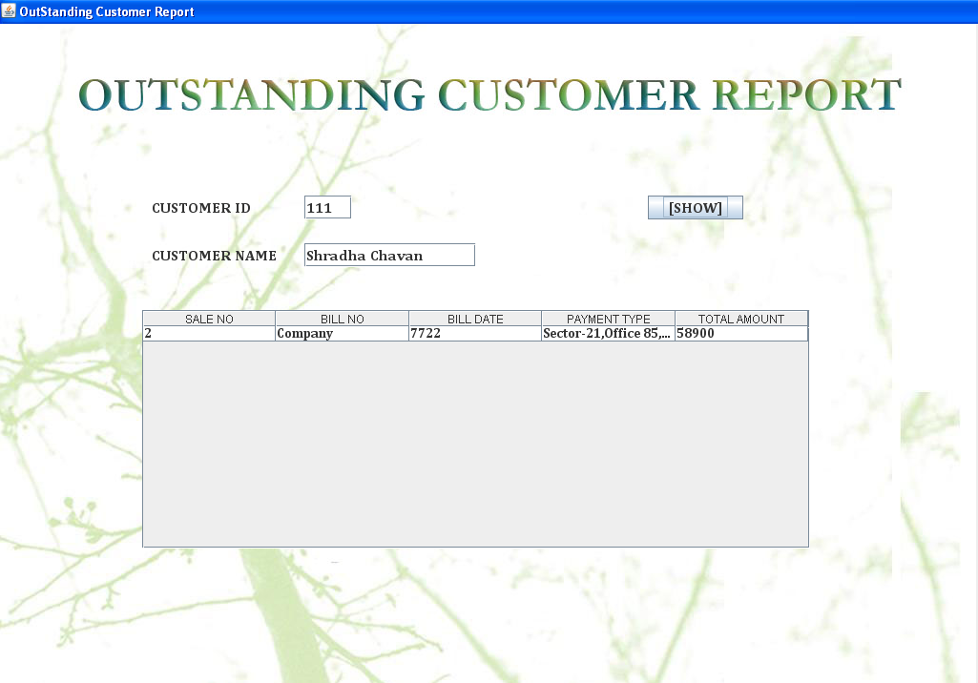

VILLAGE REPORT
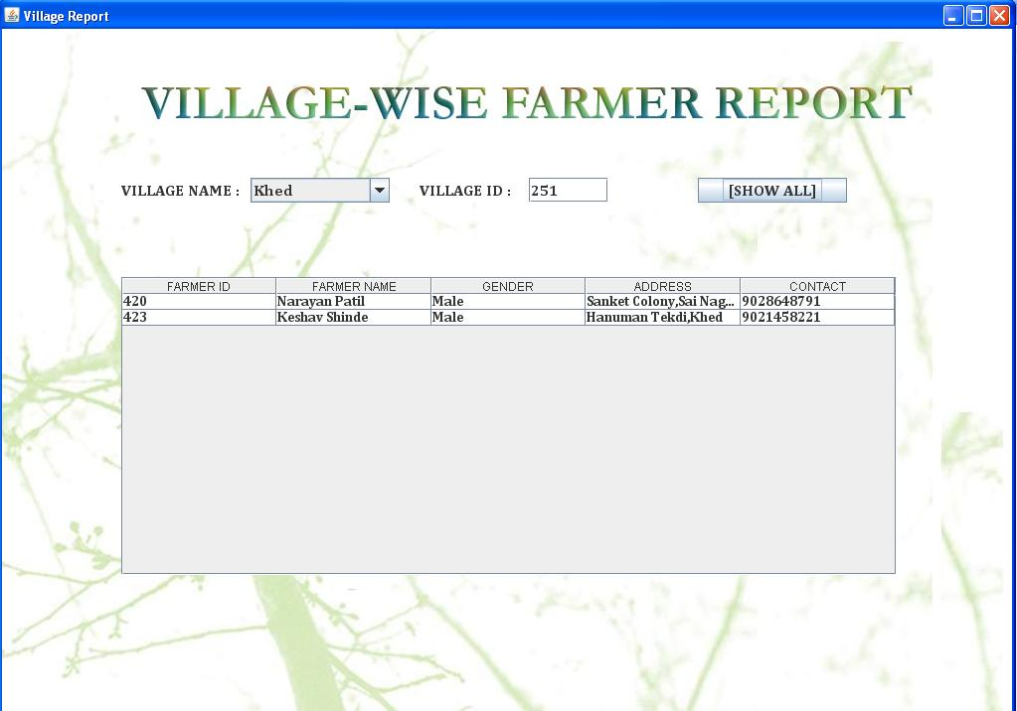

 | BIBLIOGRAPHY

BOOK REFERED:

  - Java Complete Reference 1.4
  - Beginner’s Guide To Java

WEBSITE REFERED:

- www.programsourcecode.com
- www.google.com

